Road Building Management Report

In order to maximize revenue from tree harvesting through minimizing road building costs, the optimal route of roads to build would be:

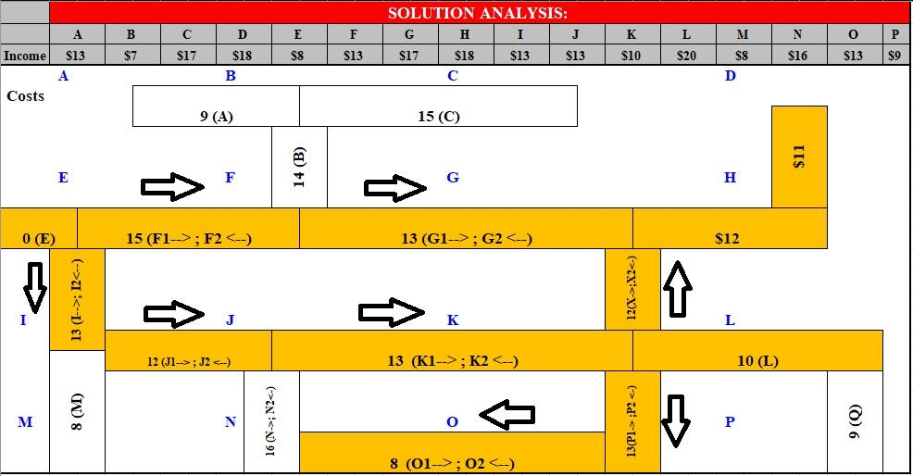

With this route, the projected profit will be $44 million.

| Constraint | Proof of constraint being followed |
| --- | --- |
| 4A - 7B + 2C + 7D + 8E - 2F1 - 7F2 + 4G1 + 0G2 + 6H - 5I1 + 0I2 + 1J1 + 1J2 - 3K1 + 0K2 + 10L + 0M - 3N1 + 0N2 + 5O1 + 8O2 - 3P1 + 0P2 + 0Q + 5X1 - 2X2 = 44 | 4(0) - 7(0) + 2(0) + 7(1) + 8(1) - 2(1) - 7(0) + 4(1) + 0(0) + 6(1) - 5(0) + 0(1) + 1(1) + 1(0) - 3(1) + 0(0) + 10(1) + 0(0) - 3(0) + 0(0) + 5(0) + 8(1) - 3(0) + 0(1) + 0(0) + 5(1) - 2(0) = 44  44 = 44 |
| A - B <= 0 | 0 - 0 <= 0  0 <= 0 |
| B - F1 - F2 - G1 - G2 <= 0 | 0 - 1 - 0 - 1 - 0 <= 0  -2 <= 0 |
| C - B <= 0 | 0 - 0 <= 0  0 <= 0 |
| D - H <= 0 | 1 - 1 <= 0  0 <= 0 |
| F1 - E <= 0 | 1 - 1 <= 0  0 <= 0 |
| F2 - G2 <= 0 | 0 - 0 <= 0  0 <= 0 |
| G1 - F1 <= 0 | 1 - 1 <= 0  0 <= 0 |
| G2 - H - X1 <= 0 | 0 -1 - 1 <= 0  -2 <= 0 |
| H - G1 - X1 <= 0 | 1 - 1 - 1 <= 0  -1 <= 0 |
| I1 - J2 <= 0 | 0 - 0 <= 0  0 <= 0 |
| I2 - E - F1 - F2 <= 0 | 1 - 1 - 1 - 0 <= 0  -1 <= 0 |
| J1 - I2 <= 0 | 1 - 1 <= 0  0 <= 0 |
| J2 - K2 - N1 <= 0 | 0 - 0 - 0 <= 0  0 <= 0 |
| K1 - J1 - N1 <= 0 | 1 - 1 - 0 <= 0  0 <= 0 |
| K2 - L - P1 - X2 <= 0 | 0 - 1 - 0 - 0 <= 0  -1 <= 0 |
| L - P1 - K1 - X2 <= 0 | 1 - 0 - 1 - 0 <= 0  0 <= 0 |
| M - I2 - J2 <= 0 | 0 - 1 - 0 <= 0  -1 <= 0 |
| N1 - O2 <= 0 | 0 - 1 <= 0  -1 <= 0 |
| N2 - J1 - J2 - K1 - K2 <= 0 | 0 - 1 - 0 - 1 - 0 <= 0  -2 <= 0 |
| O1 - N2 <= 0 | 0 - 0 <= 0  0 <= 0 |
| O2 - P2 <= 0 | 1 - 1 <= 0  0 <= 0 |
| P1 - O1 <= 0 | 0 - 0 <= 0  0 <= 0 |
| P2 - L - K1 - K2 <= 0 | 1 - 1 - 1 - 0 <= 0  -1 <= 0 |
| Q - L <= 0 | 0 - 1 <= 0  -1 <= 0 |
| X1 - K1 - K2 - L <= 0 | 1 - 1 - 0 - 1 <= 0  -1 <= 0 |
| X2 - G1 - G1 - H <= 0 | 0 - 1 - 0 - 1 <= 0  -2 <= 0 |
| A <= 1 | 0 <= 1 |
| B <= 1 | 0 <= 1 |
| C <= 1 | 0 <= 1 |
| D <= 1 | 1 <= 1 |
| E = 1 | 1 <= 1 |
| F1 <= 1 | 1 <= 1 |
| F2 <= 1 | 0 <= 1 |
| F1 + F2 <= 1 | 1 + 0 <= 1  1 <= 1 |
| G1 <= 1 | 1 <= 1 |
| G2 <= 1 | 0 <= 1 |
| G1 + G2 <= 1 | 1 + 0 <= 1  1 <= 1 |
| H <= 1 | 1 <= 1 |
| I1 <= 1 | 0 <= 1 |
| I2 <= 1 | 1 <= 1 |
| I1 + I2 <= 1 | 0 + 1 <= 1  1 <= 1 |
| J1 <= 1 | 1 <= 1 |
| J2 <= 1 | 0 <= 1 |
| J1 + J2 <= 1 | 1 + 0 <= 1  1 <= 1 |
| K1 <= 1 | 1 <= 1 |
| K2 <= 1 | 0 <= 1 |
| K1 + K2 <= 1 | 1 + 0 <= 1  1 <= 1 |
| L <= 1 | 1 <= 1 |
| M <= 1 | 0 <= 1 |
| N1 <= 1 | 0 <= 1 |
| N2 <= 1 | 0 <= 1 |
| N1 + N2 <=1 | 0 + 0 <= 1  0 <= 1 |
| O1 <= 1 | 0 <= 1 |
| O2 <= 1 | 1 <= 1 |
| O1 + O2 <= 1 | 0 + 1 <= 1  1 <= 1 |
| P1 <= 1 | 0 <= 1 |
| P2 <= 1 | 1 <= 1 |
| P1 + P2 <= 1 | 0 + 1 <= 1  1 <= 1 |
| Q <= 1 | 0 <= 1 |
| X1 <= 1 | 1 <= 1 |
| X2 <= 1 | 0 <= 1 |
| X1 + X2 <= 1 | 1 + 0 <= 1  1 <= 1 |